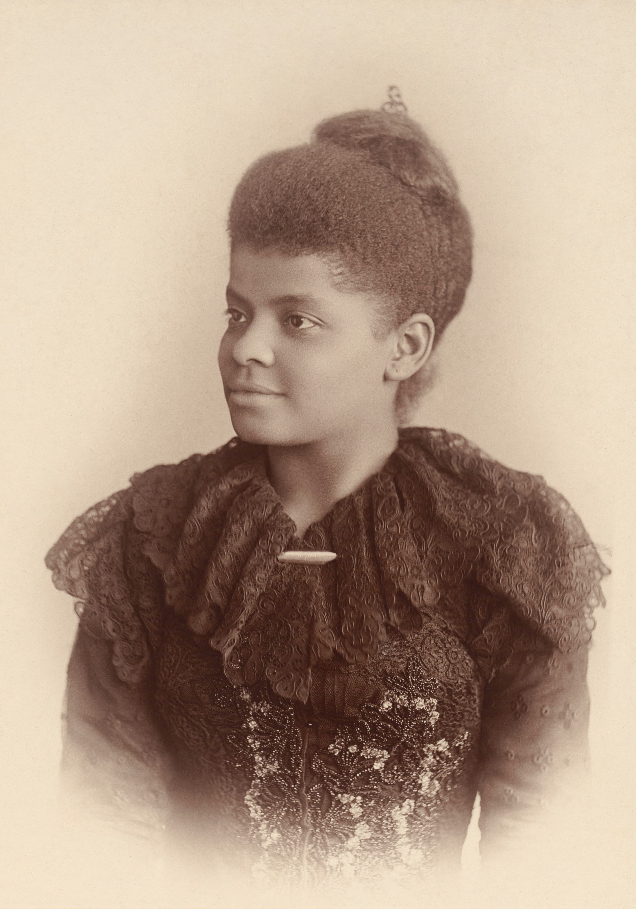
8th Annual Ida B. Wells Philosophical Conference
Friday, December 5 through Saturday, December 6, 2014
University of Memphis
Memphis, TN 38152

Advisor: Dr. Luvell Anderson
Coordinator: Corey L. Barnes

Call for Papers:
The Ida B. Wells Philosophical Association invites submissions of papers for the annual Ida B. Wells Philosophical Conference that will be held on December 5 – 6, 2014. We welcome submissions in all areas of study that engage the experiences of minorities including, but not limited to, African Americans, Latin Americans, and Americans of Middle Eastern descent, etc. The Ida B. Wells Philosophical Conference is dedicated to furthering interdisciplinary discourse regarding circumstances and problems such as gender, race, prejudice, sexual orientation, nationhood, etc. that confront minorities in the United States, as well as providing a context in which both minority undergraduate and graduate students can be connect and be encouraged in their philosophical aspirations.

Keynote speakers: Linda Alcoff, Ph.D., City University of New York
Paul Taylor, Ph.D., Pennsylvania State University

Paper submission deadline: Thursday, October 30, 2014

Eligibility for submission: Senior year Undergraduate and Masters students in the 2014-2015 academic year are eligible. (While submissions from all fields of study will be considered, preference will be given to students intending to enroll in a Masters or Doctorate program in philosophy the following academic year.)

Submission Instructions: Papers should not exceed 3000 words and are to be submitted electronically (PDF or Word) as an email attachment to the contact person below. Please provide an abstract of your submission, curriculum vitae, and a personal statement that you would like to be placed in the program of the conference upon acceptance of your submission. We will confirm receipt of submission by email within 24 hours of submission. We will also notify you (by the email address you provide) if you have been selected as a presenter for the conference. If you are selected as a presenter, you will have a total of 35-minutes allotted for your total presentation (20-minutes in which you present your written work, 10-minutes for questions from selected respondents, and roughly 5-minutes for answering questions from the audience).

Contact: Corey L. Barnes
Email: clbrnes1@memphis.edu

Ida B. Wells Philosophical Association
University of Memphis
Department of Philosophy
327 Clement Hall
Memphis, TN 38152

