The link of campus map:
http://www.cornell.edu/about/maps/Cornell-campus-map-072213.pdf
The link of parking on campus: https://transportation.fs.cornell.edu:8496/parking/campusparking/default.cfm

1. Walking from Hotel Ithaca to the conference venue (42 min):

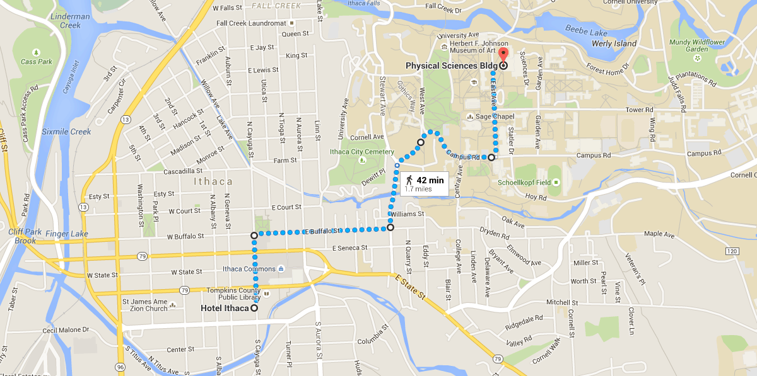

Head north on S Cayuga St toward W Green St (0.3 mi)
Turn right onto E Buffalo St (0.5 mi)
Turn left onto Stewart Ave (0.2 mi)
Slight right onto Campus Rd (0.4 mi)
Turn left onto East Ave (0.3 mi)
The Physical Science Building will be on the right

2. Taking bus from Hotel Ithaca to the conference venue (ticket price: $1.5)

(1) Walking from Hotel Ithaca to the bus stop (3 min)

Head north on S Cayuga St toward W Green St (374 ft)
Turn right onto NY-79 E/E Green St (449 ft)
The Commons/Green St bus stop will be on the right

(2) There are not many buses going to Cornell campus on July 26 (Sunday). If People want to take a bus, the best option in the morning is to take route 72 at 8: 00 am to the Carpenter Hall bus stop (8 min), and then walk to the Physical Science Building (9 min).

Directions of walking from the Carpenter Hall bus stop to the Physical Science Building:
Head north on Central Ave toward Campus Rd (89 ft)
Turn right onto Campus Rd (0.1 mi)
Turn left onto East Ave (0.3 mi)
The Physical Science Building will be on the right

(3) On July 27 and July 28, people can take route 30 to the Rockefeller Hall bus stop. The Physical Science Building will be on the left of Rockefeller Hall. Route 30 runs every 15 min in the morning (8: 15 am, 8: 30 am, 8: 45 am, etc.).

3. Walking from the conference venue to 515 W Clinton St. for lawn parties on Sunday and Monday

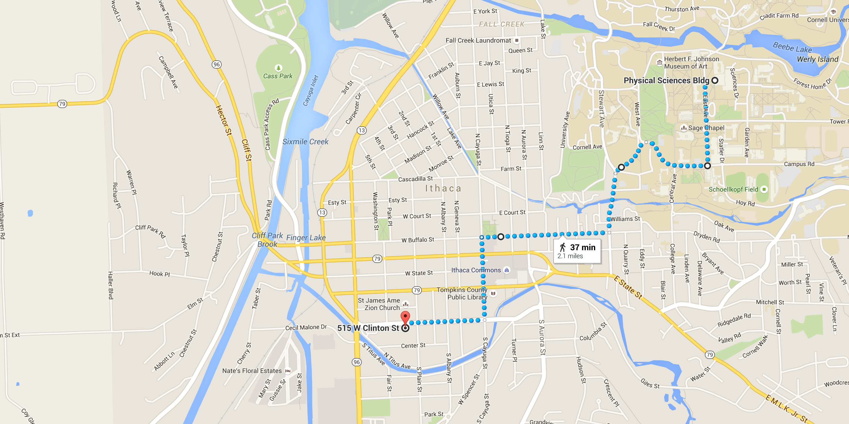

Turn right onto Campus Rd (0.3 mi)
Slight left to stay on Campus Rd (0.2 mi)
Continue onto Stewart Ave (0.2 mi)
Turn right onto E Buffalo St (0.5 mi)
Turn left onto N Cayuga St (0.3 mi)
Turn right onto W Clinton St (0.3 mi)
Destination will be on the left

