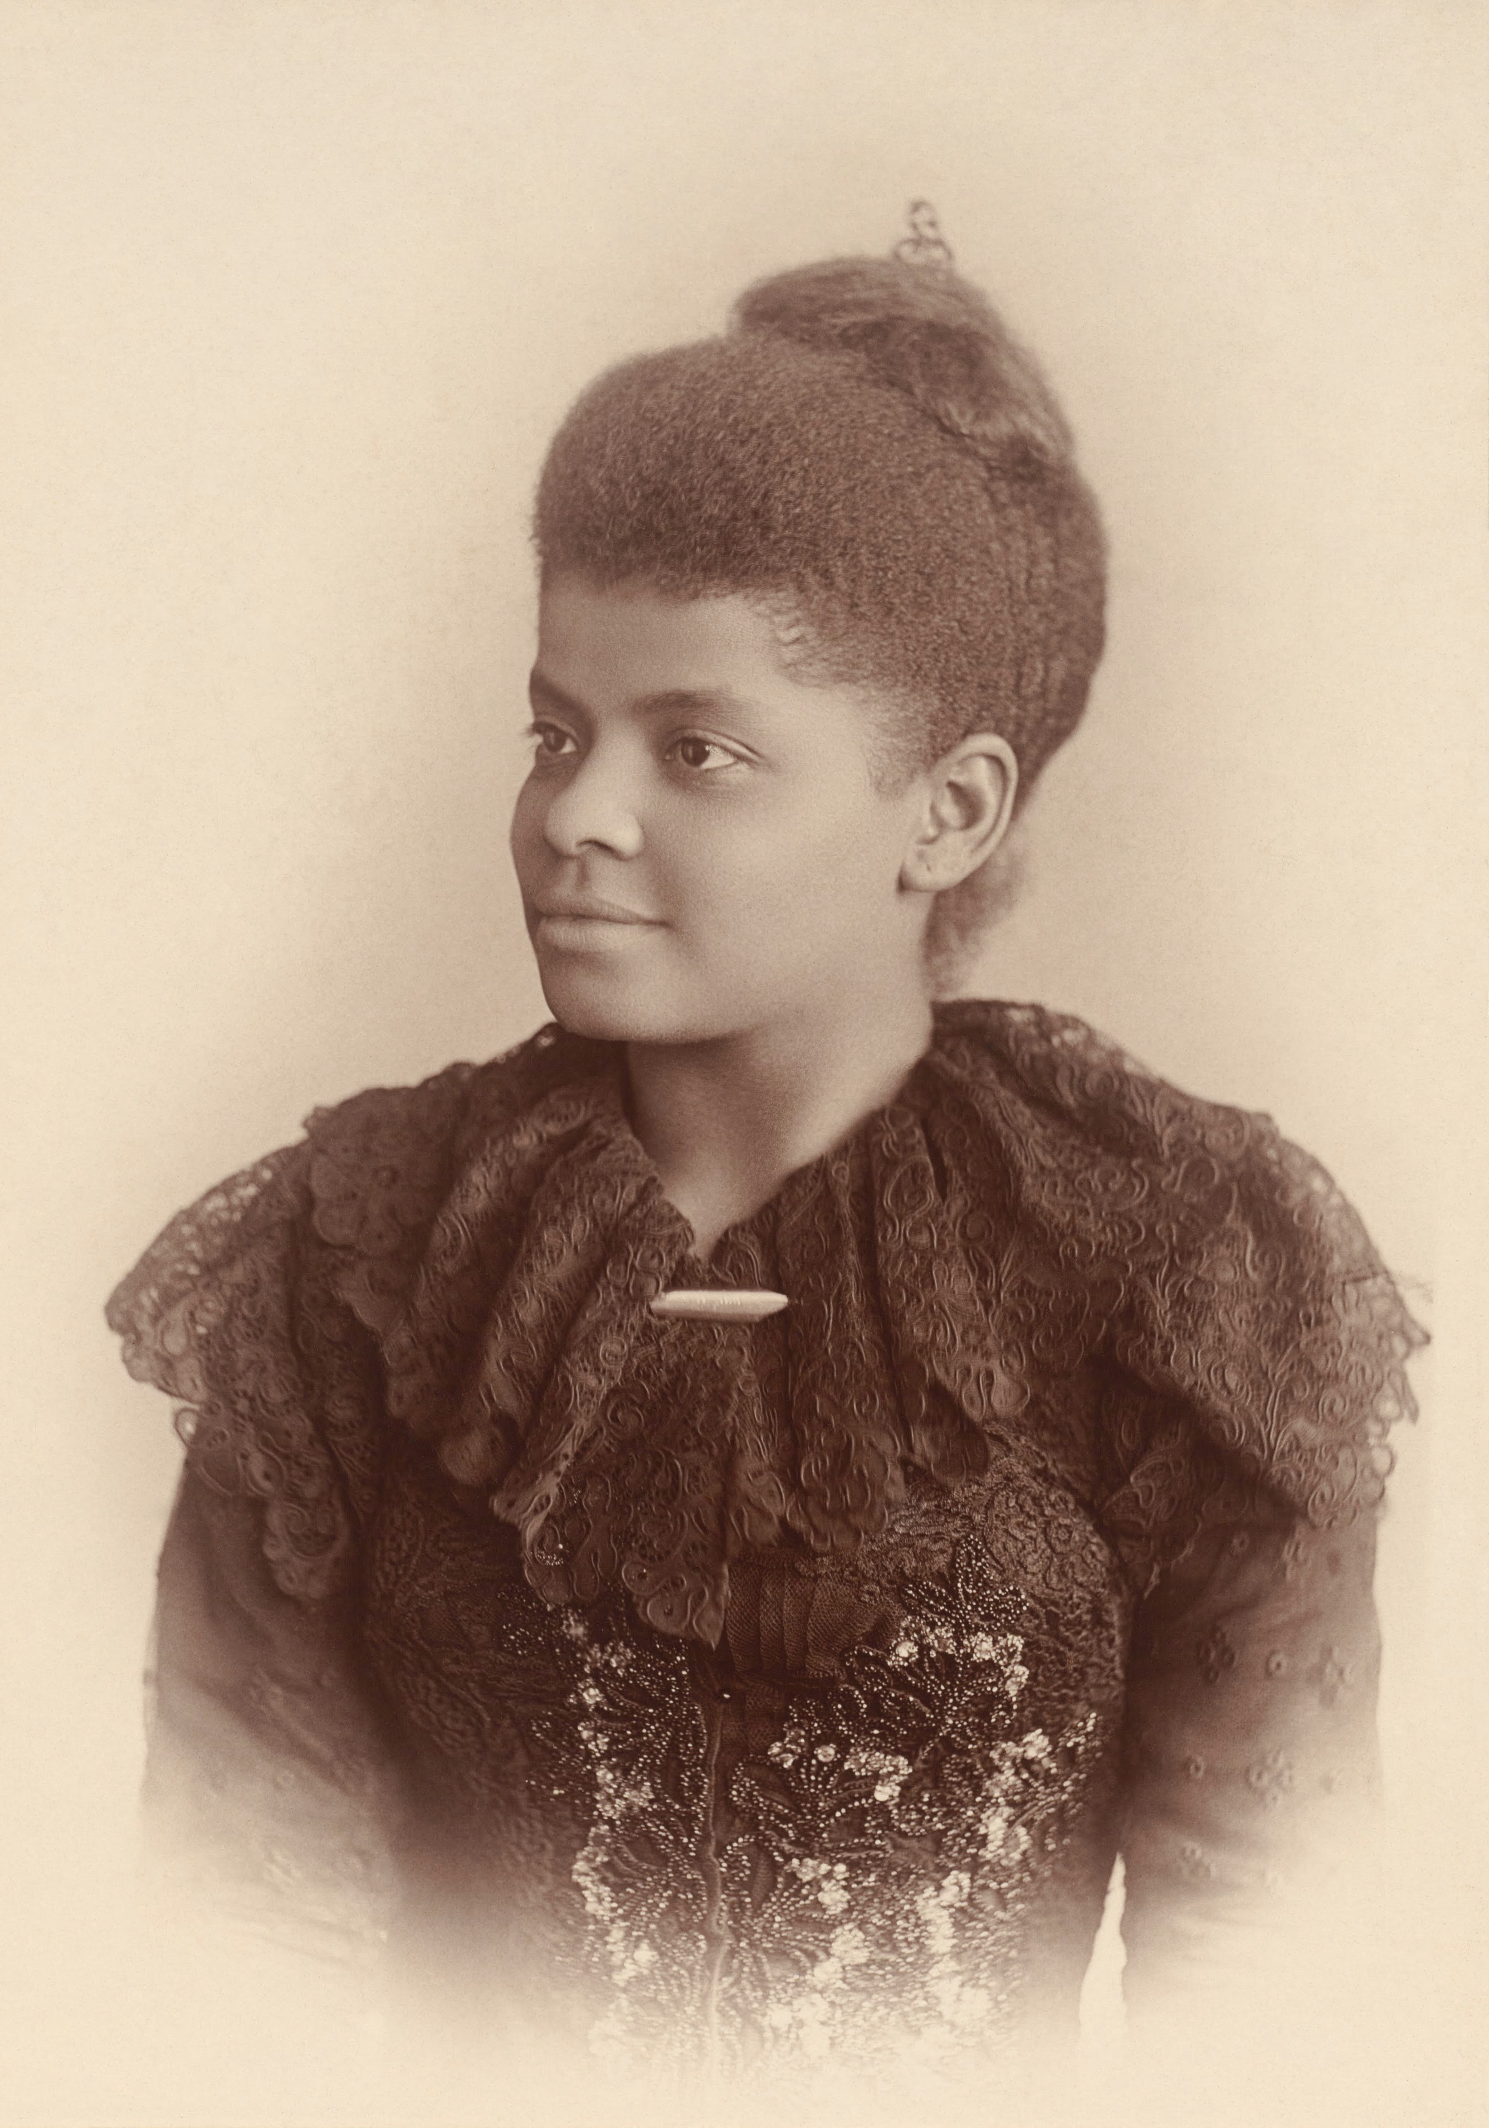
9th Annual Ida B. Wells Philosophical Conference
Friday, November 20, 2015
University of Memphis
Memphis, TN 38152

Advisor: Dr. Luvell Anderson
Coordinator: Corey L. Barnes

Call for Papers:
The Ida B. Wells Philosophical Association invites submissions of papers for our 9th annual Ida B. Wells Philosophical Conference that will be held on November 20, 2015. We welcome submissions in all areas of study that engage the experiences of minorities including, but not limited to, African Americans, Native Americans, Asian Americans, Continental Indian Americans, Pacific Americans, Latin Americans, Americans of Middle Eastern descent, Mixed-Raced Americans, etc. The Ida B. Wells Philosophical Conference is dedicated to furthering interdisciplinary discourse regarding circumstances and problems such as gender, race, prejudice, sexual orientation, nationhood, etc. that confront minorities in the United States, as well as providing a context in which both minority undergraduate and graduate students can be connect and be encouraged in their philosophical aspirations.

Keynote speakers: Quayshawn Spencer, The University of Pennsylvania

Paper submission deadline: Saturday, October 10, 2015

Eligibility for submission: Senior year Undergraduate, Masters, and Doctoral students for the 2015-2016 academic year are eligible. (While submissions from all fields of study will be considered, preference will be given to students in Undergraduate, MA, and PhD programs in philosophy.)

Submission Instructions: Papers should not exceed 3000 words and are to be submitted electronically (PDF or Word) as an email attachment to the contact person below. Please provide an abstract of your submission, curriculum vitae, and a personal statement that you would like to be placed in the program of the conference upon acceptance of your submission. We will confirm receipt of submission by email within 24-hours of submission. We will also notify you (by the email address you provide) if you have been selected as a presenter for the conference. If you are selected as a presenter, you will have a total of 35-minutes allotted for your total presentation (20-minutes in which you present your written work, 10-minutes for questions from selected respondents, and roughly 5-minutes for answering questions from the audience).

Contact: Corey L. Barnes
Email: clbrnes1@memphis.edu

Ida B. Wells Philosophical Association
University of Memphis
Department of Philosophy
327 Clement Hall
Memphis, TN 38152

