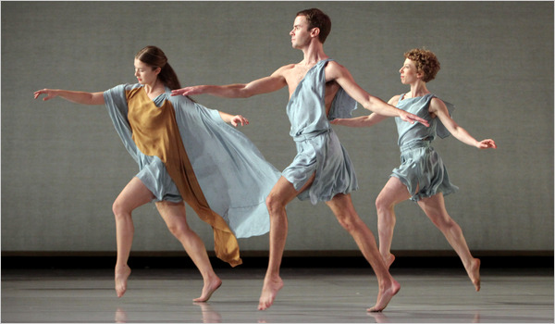
Texas State University

Texas State University
Department of Philosophy
Division of Dance
American Society for Aesthetics

[Sidebar Title]
Engagement: Symposium for Philosophy of Dance and Performance

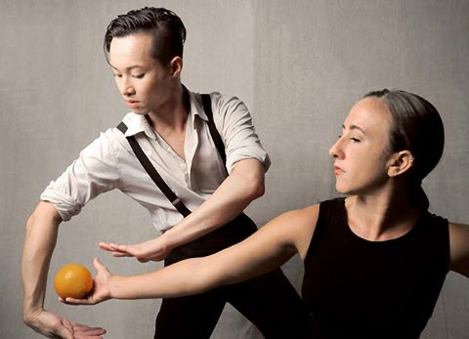

Call for Papers/Panels: “Engagement: Symposium for Philosophy of Dance and Performance”
We invite scholars to submit abstracts for an interdisciplinary symposium investigating philosophy and dance. Featuring live performances and keynote speakers from the fields of ballet, modern, and popular dance, aesthetics, philosophy of art, dance theory, choreography, and multi-media dance; the symposium will also include interdisciplinary panels for scholars, practitioners, and students, and will result in a book and two special issues of scholarly journals. Invited keynote speakers include, Julie Van Camp, Arnold Berleant, Richard Shustermann, Robert Crease, and Barbara Montero. The performing dance companies will be Mark Morris Dance Company (Brooklyn, New York), Erick Hawkins Dance Company (NYC, New York), and ARCOS (Austin, Texas).
We plan an exploration of aspects of dance that impact our understanding of what it means to be a human being, through discussion and dialogue as well as practice and performance. There will be workshops and master-class sessions held in conjunction with the symposium.
Please note: We invite individual papers, as well as panels of professors and students.
Papers are to be limited to 20 minutes to allow time for discussion. Please submit a 250-300 word abstract, and a CV or professional bio.
Panels will be scheduled for 1-hour, and can include 3-5 participants. Please submit a 500-600 word abstract of your topic and panel, along with the names and short bios or CVs of panel participants.
What: Engagement: Symposium for Philosophy of Dance and Performance
Where: Texas State University, San Marcos, Texas
When: September 8 - 10, 2016
Submit Proposals and Learn More: www.txstate.edu/philosophy/SymposiumPhilosophyDancePerformance.html

SUBMISSION DEADLINE: 1 June 2016

