Department of Philosophy and Humanities, University of Texas at Arlington
Call for Papers
Austrian Thought at the Turn of the 20th Century
November 1-3, 2012
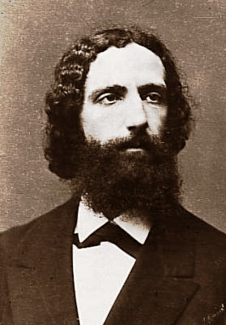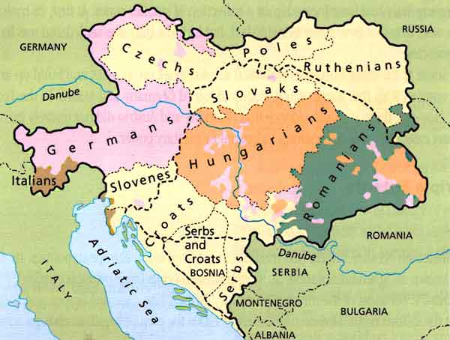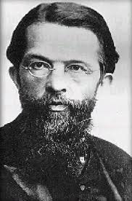
We invite contributions to a conference on Austrian Thought at the Turn of the 20th Century. Philosophers of this period of the Austro-Hungarian Empire—led by Franz Brentano—advanced myriad areas of philosophy and innovative psychological research (e.g., Gestalt theory, the Graz School of experimental psychology). Additionally, economists—led by Carl Menger—set forth the theory of subjective value, which prepared the ground for a new conceptual framework for economics. Together, Austrian philosophers and economists collaborated on applications of the notion of intentionality, value theoretical investigations, and the description of social and psychological phenomena.

We seek innovative contributions that draw from or deepen our understanding of the legacy of Austrian philosophy, Austrian economics, or Austrian psychology. For the purposes of this conference, we are demarcating the Brentanian tradition as that which starts with Brentano and culminates in the work of the students of his students, such as Stein, Reinach, Ingarden, Witasek, Leśniewski, Łukasiewicz. Similarly, for the purposes of this conference we are demarcating the Mengerian tradition as that which starts with Menger and culminates in the contributions of the last generation of economists of this School who are Austrian nationals. Suggested categories for papers are:

- Austrian philosophy and the Austrian School of economics
- The Austrian tradition of psychology and philosophy of mind and its influence in later developments in cognitive science and neuroscience
- Social objects and social ontology
- Stein and her description of empathy, and corroborating findings in science, including research in neuroethics and neurophenomenology
- Phenomenology (e.g., Husserl, mereology, intersubjectivity, constitution, the Göttingen Circle)
- Aesthetics (e.g., Musil, Kafka, Ingarden)
- Polish philosophy and the Lvov-Warsaw School (e.g., Twardowski and his students, semantics and truth)
- Relations between the Brentano School and the Vienna Circle
- Relations between the Brentano School and Wittgenstein
- Relations between the Brentano School and Freud

EXTENDED Deadline for Submissions: August 31, 2012
Abstracts may not be longer than 500 words and should be prepared for blind reviewing with a second page indicating name, affiliation, and title of abstract. Details for submission and registration are in the conference web page: http://www.uta.edu/philosophy/ATC.html Please send any questions to the Conference Chair, Gloria Zúñiga y Postigo (gloria.zunigaypostigo@uta.edu).

