CALL FOR PAPERS
The 2018 Harvard-MIT
Graduate Conference in Philosophy

We invite submissions from graduate students for a conference hosted by the Philosophy Departments at Harvard University and MIT to be held on February 17, 2018 at MIT. We will consider submissions in all areas of philosophy, but particularly encourage submissions concerning causation, agency, free will, moral responsibility, and other issues at the intersection of metaphysics, philosophy of action, and moral theory, as well as the historical development of philosophical thought in these areas.

Keynote Speaker:
Carolina Sartorio
Associate Professor of Philosophy
University of Arizona

The deadline for submission of papers is December 15th, 2017.

Guidelines:
- Submit papers to harvardmit2018gradconf@gmail.com by December 15th, 2017. Papers should be no more than 4000 words, with abstracts of no more than 250 words, and must be suitable for a 40-45 minute presentation. All submissions must be in PDF or Word formats. Papers should be prepared for blind review.
- Submit a separate cover letter in PDF or Word format with the following details: name, paper title, institutional affiliation, and contact information.
- Authors must be current graduate students in philosophy. Co-authored papers are permitted if all authors are current graduate students.
- Successful applicants will be contacted by January 16th, 2018.
- Send questions or concerns to harvardmit2018gradconf@gmail.com.

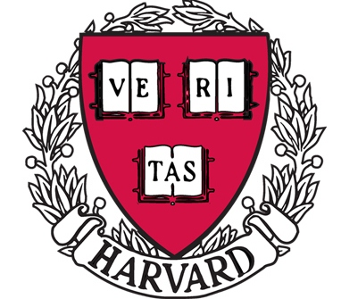
Hosted jointly by the Department of Philosophy, Harvard University, and the Department of Linguistics and Philosophy, Massachusetts Institute of Technology

