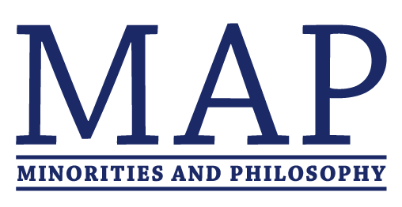

NY-MAPWorks
A Philosophy Workshop Series
Spring 2018 Program

Feb. 20th, 7-8:45pm @ New School (6 E 16th, Wolff Conf. Room (1103))
Sofia Ortiz-Hinojosa (Vassar), "Virtue Epistemology in Sor Juana"
Martin Abreu Zavaleta (NYU), "Communication and Variance"

March 6th, 7-8:45pm @ CUNY Grad Center (365 5th Ave, Room C205)
Aaron Landau (Columbia), “Learning from Injustice: Pragmatism as Nonideal Theory”
Dee Payton (Rutgers), “Processing Blame on Fragmented Grounds”

April 17th, 7-8:45pm @ Columbia (405 Kent Hall)
Fatema Amijee (Simon Fraser), "Feminist Islam"
Filipa Melo Lopes (Michigan), “Gender and the Social Standing Thesis”

May 8^{th,} 7-8:45 @ NYU (5 Washington Pl., Room 202)
Wendy Salkin (Harvard), “Democracy Within, Justice Without: The Duties of Informal Political Representatives”
Shannon Brick (CUNY), "Can Pictures Make Us Morally Better?”

NY-MAPWorks is a joint initiative of the Minorities and Philosophy (MAP) chapters of Columbia, The CUNY Graduate Center, NYU, Rutgers, and The New School. Talks will be followed by a reception (8:45-9:30pm).

