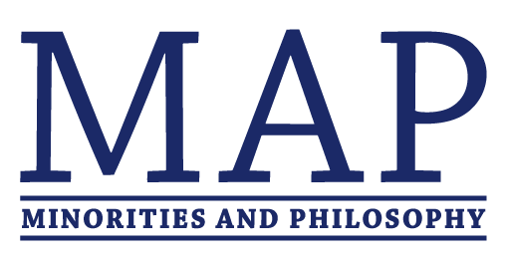




The Minorities and Philosophy Chapters of The Graduate Center CUNY, New York University, Princeton, Columbia, Rutgers, and the New School present

Oppression and Resistance:
A conference on understanding and resisting oppression inside and outside the academy.
October 12-13, 2018
Department of Philosophy, New York University, 5 Washington Place
Keynote Speaker: José Medina, Walter Dill Scott Professor, Northwestern University

Friday Oct 12
Panel 1 – MAP Organizing: 1.00-2.00pm (6th Floor)
Elise Woodard, Carolina Flores, Keyvan Shafiei
Panel 2 – Graduate Employee Unions and Social Justice: 2.10-3.10pm (6th Floor)
Danny Echikson, Nadia Mehdi, Chris Nickell
Panel 3 – Teaching Outside the Academy & Inclusive Pedagogy: 3.20-4.20pm (6th Floor)
Sukaina Hirji, Allysa Lake, Victoria Emery
Panel 4 – Faculty Panel on Activism and Public Philosophy: 4.30-6.30pm (202)
Linda Martín Alcoff, Lori Gruen, Briana Toole, Kate Ritchie
Reception: 6.30-7.30pm

Saturday Oct 13
Session 1: 10.00-11.30am (101)
Rebecca Harrison, “Experiencing Resistance: Disruptive Protest as a Site of Moral Learning”
Claryn Spies, “Ideas Spring from Deeds: Rethinking Black Bloc Aesthetically”
Session 2: 11.45am-1.15pm (101)
Noel Dominguez, “Are We Blameworthy for Implicit Biases? We Might As Well Be”
Javiera Perez-Gomez, “Microaggressions: Failings and Prospects”
Session 3: 2.30-4.00pm (101)
Emmalon Davis, “What We Owe to Ourselves: Resisting a Self-Directed Duty to Resist Oppression”
Matt Andler, “What Is Sexual Identity?”
Keynote: 4.30-6.30pm (101)
José Medina, "Resisting Racist Propaganda: Distorted Visual Communication and Epistemic Activism"
Reception: 6.30-7.30pm
Supported by the New School Student Senate, the New York Institute of Philosophy, and the philosophy departments at Columbia, the CUNY Graduate Center, Rutgers, and Princeton.

