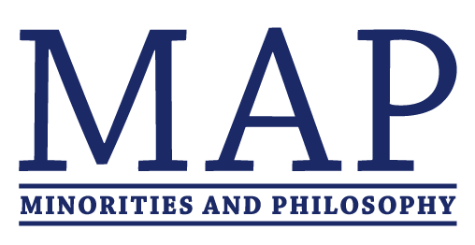

Call for Participants
Oppression and Resistance
New York University, October 12-13, 2018

The Minorities and Philosophy (MAP) chapters of Columbia, the CUNY Graduate Center, the New School, NYU, Princeton, and Rutgers invite applications for engaged participants in the conference/workshop ‘Oppression and Resistance’, a Fall 2018 conference that will feature philosophical talks related to this theme as well as and practical workshops on topics related to activism and philosophy. This is a call for engaged participants in the practical workshops (who would be expected to attend the entire conference). There is a separate call for abstracts here.

Who Should Apply: We are seeking applications from philosophers at any career stage who have done significant activist and/or service work. This includes but is not limited to work in: Anti-Racist Activism, Diversifying Philosophy as a Profession, Fighting Gender-Based Discrimination and Violence, Inclusive Pedagogy, Labor Organizing, Public Philosophy, Teaching in Non-Standard Contexts. We especially encourage applications from groups underrepresented in philosophy, including individuals underrepresented on the basis of gender, race, sexual orientation, class, and disability.

Your Role in the Conference: We will be running practical workshops relevant to the topics above and to activism and philosophy more generally. Engaged participants will be expected to share their activist experience in this context and to actively seek to form new connections so as to develop collaborative projects in the future. We will be able to provide housing with a graduate student and to offer limited travel funding.

Submission Guidelines: To apply, please complete the following by June 30, 2018:
1) Send in PDF format (a) your CV and (b) a short description (up to 300 words) of your relevant experience in activism broadly construed and/or service work within philosophy. These should both be prepared for blind review. Email these to nymapshop@gmail.com.
2) Provide your contact information by completing this google form.

