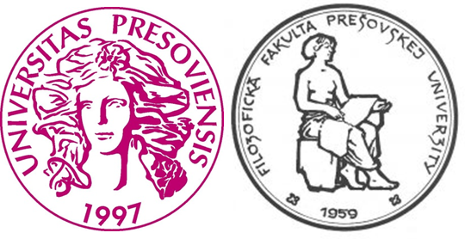

UNESCO Chair in Bioethics and Institute of Ethics and Bioethics
at Faculty of Arts, University of Prešov
organize

19th International Conference Ethical thinking - Past and Present (ETPP 19/2018)

Man and Death: The Ethical and Philosophical Aspects
of Death and Dying.

13th – 14th September 2018
Stará Lesná, Slovakia

Application form

Name:

Affiliation:

Email:

Title of the article:

Abstract in English (200-250 words)

Keywords:

Accommodation:
12th – 13th September 2018 Y – N
13th – 14th September 2018 Y – N
14th – 15th September 2018 Y – N

Type of Room:
- Single
- Twin room (please, mark the name of the person, you are going to share the room with)
- 3-beds room (please, mark the name of persons, you are going to share the room with)

Conference Dinner:
Y – N

