Map of Marquette University
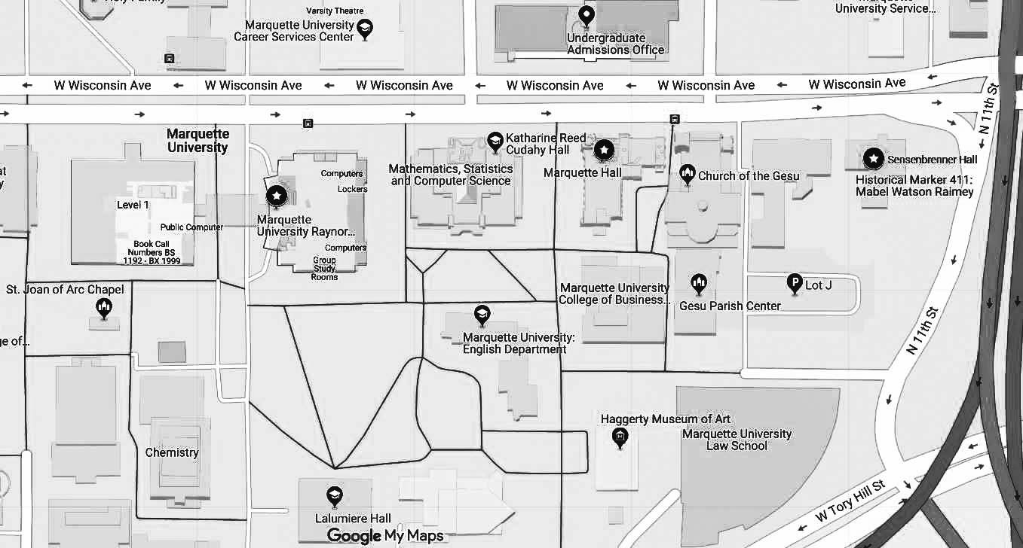
To Ambassador Hotel

Generously funded by
The Helen Way Klingler College of Arts and Sciences, Marquette University
The Department of Philosophy, Marquette University
The Office of Research and Innovation, Marquette University
The Center for the Advancement of the Humanities, Marquette University
American Friends of Humboldt

Marquette University Philosophy Department

Conference | February 20-21, 2020
Themes from the Philosophical Scholarship of Sarah Broadie

2020 Aquinas Lecture | February 23, 2020
Mathematics in Plato’s Republic
Sarah Broadie (University of St. Andrews)

Day 1 | 20 Feb 2020
Eisenberg Room, Sensenbrenner Hall

Session A Chair: Richard Tierney (UW Milwaukee)

10:00-11:15 Mary Spencer Krizan (University of Wisconsin La Crosse)
Distinguishing Principles in Aristotle’s Elemental Transformations
11:15-11:30 Coffee break

11:30-12:45 Aparna Ravilochan (University of Chicago)
Following Broadie to a Revision of Natural Efficient Cause
12:45-2:00 Lunch

Session B Chair: Owen Goldin (Marquette University)

2:00-3:15 Christopher Frey (University of South Carolina)
Plato and Aristotle on What Desires Form
3:15-3:20 Break

3:20-4:35 Jessica Moss (New York University)
The Demiurge and the Philosopher-Kings

4:35-4:50 Coffee break

4:50-6:05 Naomi Reshotko (University of Denver)
From the Cosmology of the Timaeus, through the Metaphysics of Anankê, to the Epistemology of the Forms

7:00 Dinner
Day 2 | 21 Feb 2020
Eisenberg Room, Sensenbrenner Hall

Session C Chair: Alexander P. D. Mourelatos (UT Austin)

9:00-10:15 David Chan (The University of Alabama at Birmingham)
Choosing for the Sake of the Good

10:15-10:30 Coffee break

10:30-11:45 Edward Halper (University of Georgia)
Grand Ends?

11:45-11:50 Break

11:50-1:05 Christiana Olfert (Tufts University)
Deliberating About Practical Truth
1:05-2:15 Lunch break

Session D

Chair: Thomas Olshewsky (U of Kentucky, New College of Florida)

2:15-3:30 Daniel Wolt (Bilkent University)
phronêsis and kalokagathia in Eudemian Ethics VIII 3

Aquinas Lecture | 23 Feb 2020
3:00 PM Marquette Hall Room 100

3:00 Sarah Broadie (University of St. Andrews)
Mathematics in Plato’s Republic

