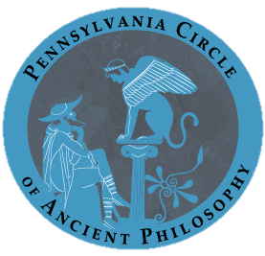
Pennsylvania Circle of Ancient Philosophy: Call For Papers

The Pennsylvania Circle of Ancient Philosophy (PCAP) is pleased to announce its inaugural conference, to be held at Duquesne University, February 16-17, 2013.

PCAP aims to promote a community of local scholars dedicated to the study of ancient philosophy. Our annual conference provides a venue for graduate students and faculty to share new research and works in progress that cut across a variety of disciplinary and methodological approaches.
We welcome submissions on any topic in Ancient Greek and Roman philosophy.
Additionally, we also welcome inquiries from anyone interested in serving as a respondent or becoming part of PCAP.

Keynote Speakers:
Patrick Miller (Duquesne University)
http://duq.edu/academics/faculty/patrick-lee-miller

Kristen Inglis (University of Pittsburgh)
http://www.philosophy.pitt.edu/people/faculty/Inglis.php

Submission Deadline: Monday, December 17, 2012.
Eligibility for Submission: Submissions will be accepted from graduate students, faculty, and independent scholars working in the state of Pennsylvania.
Submission Instructions: Abstracts of 400-500 words should be prepared for blind review and accompanied by a separate cover page listing the author's name, affiliation, and contact information. We welcome panel proposals as well as individual papers. All submissions are to be submitted electronically (PDF or Word) to PennAncient@gmail.com. We will notify you by early January if you have been selected as a participant for the conference.

In order to encourage informed dialogue, each participant will be requested to submit his or her paper and read the papers of other participants in advance. Full papers suitable for a twenty-minute presentation (no more than 3000 words) will be required no later than Monday, January 28, 2012.

http://pennsylvaniacircleofancientphilosophy.wordpress.com/

